

Name: Abdelatef Osama Abdelatef Torky
DR/Mohamed Abdelhamed
Report 4 => eigrp

Objective
To Achieve Routing Protcol eigrp
Tools
Cisco Packet Tracker
Subject
The project demonstrates the implementation of dynamic routing using Enhanced Interior Gateway Routing Protocol (EIGRP) to enable communication between different networks. The network is designed using IPv4 addressing without using Network Address Translation (NAT), as the devices communicate directly through routing tables.
The routers are connected through the serial network 50.0.0.0/30, where the router interfaces use addresses such as 50.0.0.1 and 50.0.0.2 to establish connectivity. The local network 172.168.0.0/24 is connected to the router through the GigabitEthernet interface.
Using EIGRP, routers automatically exchange routing information and dynamically learn the best path to reach remote networks. After configuring EIGRP and advertising the connected networks (such as 50.0.0.0/30 and 172.168.0.0/24), packets are forwarded based on the entries in the routing table learned through EIGRP rather than using manually configured static routes.
In this design, NAT was not implemented because the network operates within internal addressing and the devices communicate directly through routing without requiring address translation.
Cisco Packet Tracker
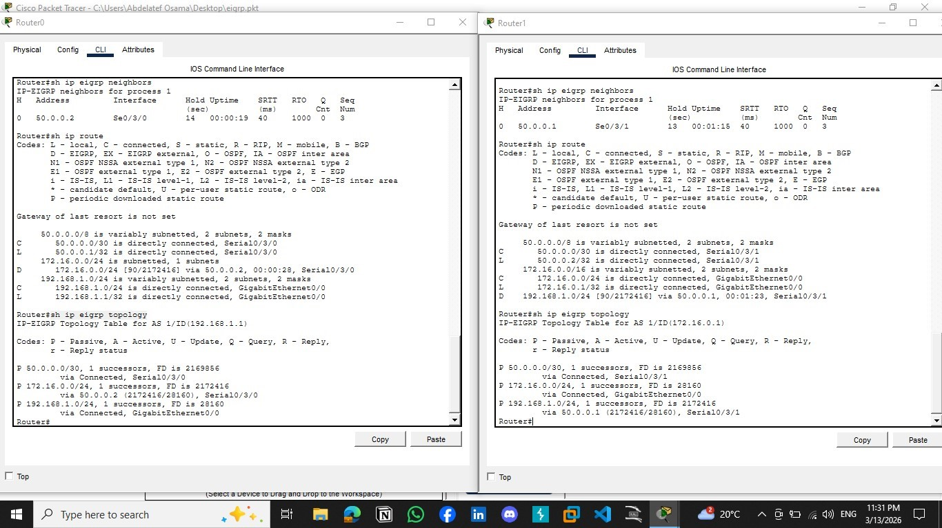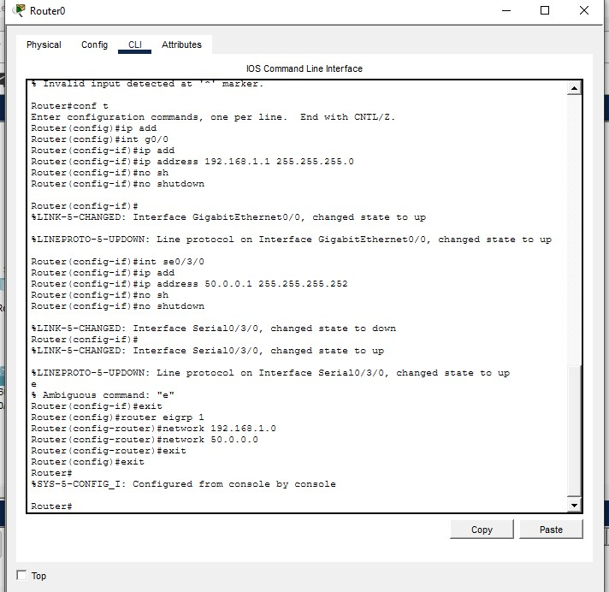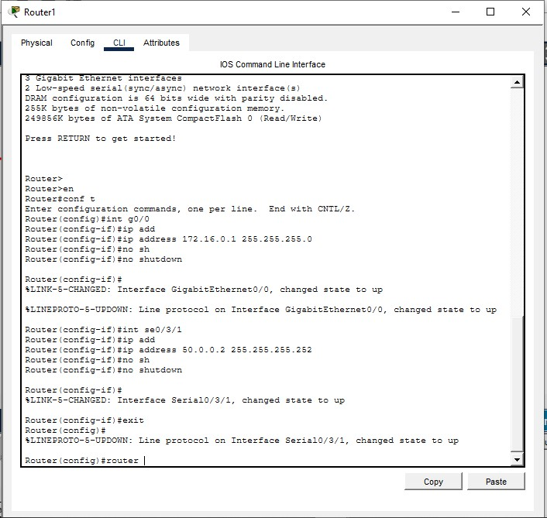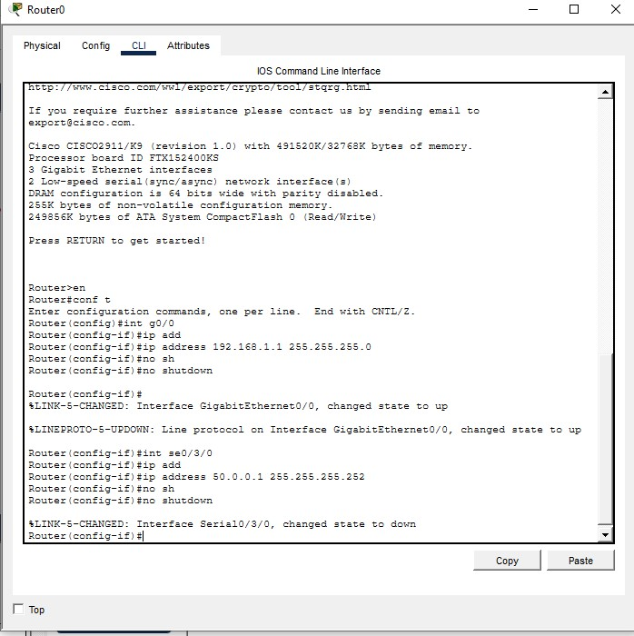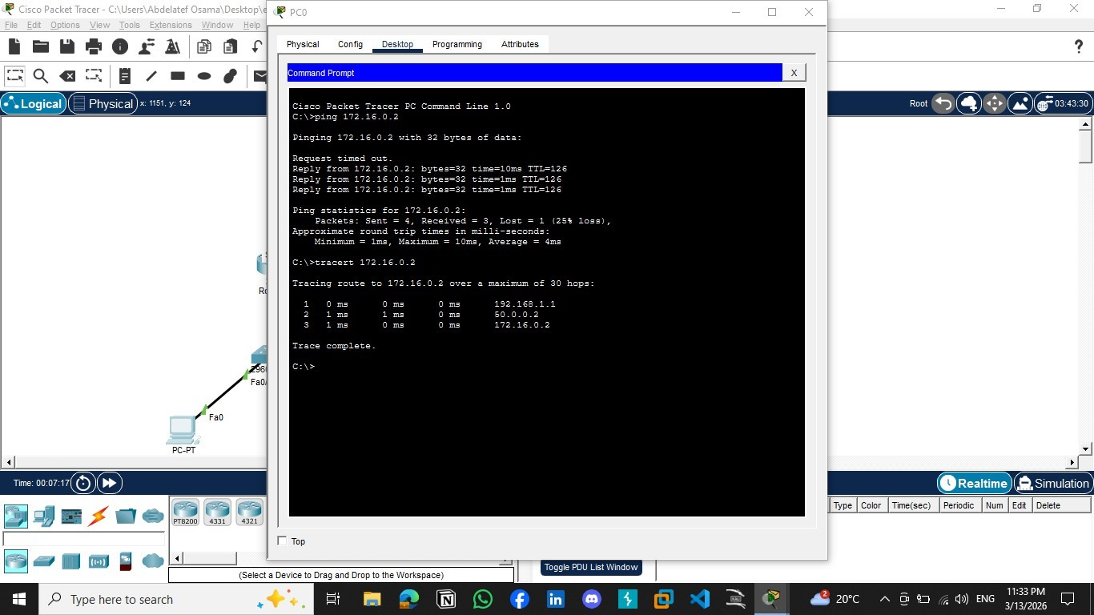

Conclusion
In conclusion, this project demonstrated the use of Enhanced Interior Gateway Routing Protocol (EIGRP) to enable communication between different networks using dynamic routing. EIGRP allows routers to automatically exchange routing information and determine the best path for data transmission without the need for manually configured routes. This improves network efficiency, simplifies network management, and provides faster convergence compared to basic routing methods. Overall, EIGRP plays an important role in building reliable and scalable network infrastructures.

